1. **Whenever an Account is created Contact should be created automatically.**

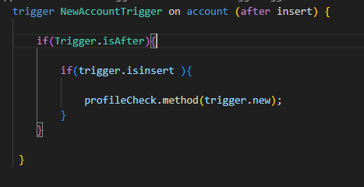

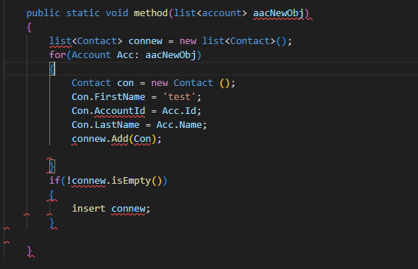

Output:

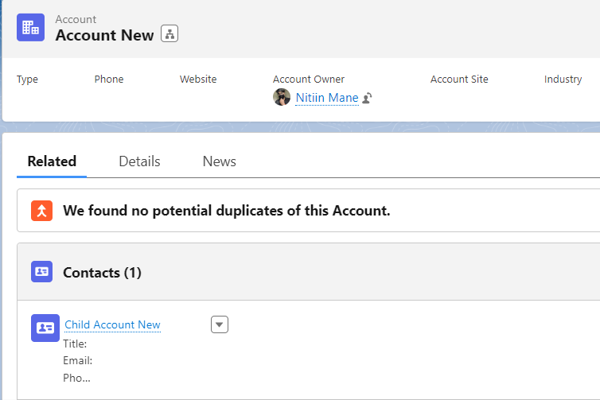

**When an opportunity is inserted or updated, if the stage name is ‘Closed won’, then add the task**

**Trigger:**

trigger newOppTrigg on Opportunity(after insert,after update)

{

    if(trigger.isafter)

    {

        if(trigger.isinsert || trigger.isupdate)

        {

            OpportunityClass.newtask(trigger.new);

        }

    }

}

Handler class:

public  class OpportunityClass

{

    public static void newtask(List<Opportunity> newtasknewoppObj)

    {

        List<Task> t1= new list<task>();

        for(Opportunity opp:newtasknewoppObj)

        {

            if(opp.StageName=='Closed Won')

            {

                t1.add(new task(subject='New Task for new opportunity',WhatId=opp.id));

            }

        }

        insert t1;

    }

}

Output:

